Git Workflow - Remote repository

From Local repository to Remote repository
# Source: AI Source: Provided by: [Data Path: Persons Table -> ID Column: 1, Name_En Column: Motasem Essam] -> From: [Chatgpt (GPT‑5 Mini)] on [2/19/2026]
Perfect! Let’s cover how to move changes from your Local Repository → Remote Repository in Git. This is essentially pushing commits to a remote like GitHub.
Once your changes are safely in your local repository (committed), you can send them to a remote repository so others can access them or so they are backed up online.

Check Your Remote
# Source: AI Source: Provided by: [Data Path: Persons Table -> ID Column: 1, Name_En Column: Motasem Essam] -> From: [Chatgpt (GPT‑5 Mini)] on [2/19/2026]
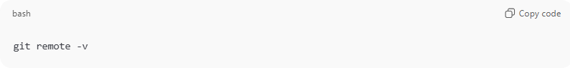
git remote -v
Explanation:
- Shows the remote repositories linked to your local repo.
- Typical remote names: origin, upstream.
- Example output:
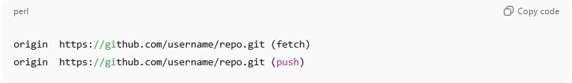
origin https://github.com/username/repo.git (fetch)
origin https://github.com/username/repo.git (push)

Upstream

What is Upstream Tracking?
# Source: AI Source: Provided by: [Data Path: Persons Table -> ID Column: 1, Name_En Column: Motasem Essam] -> From: [Chatgpt (GPT‑5 Mini)] on [2/19/2026]
Upstream tracking means:
Your local branch is linked to a remote branch, so Git knows where to push and pull by default.
When tracking is set, you don’t need to write the remote and branch every time.
Instead of:
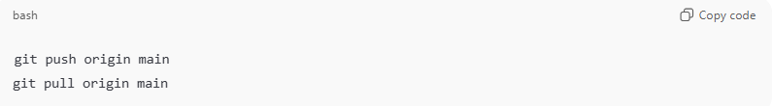
git push origin main
git pull origin main
You can simply use:
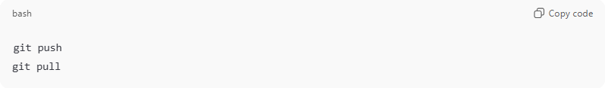
git push
git pull
Git already knows the destination branch.

What does Set Upstream Tracking mean?
# Source: AI Source: Provided by: [Data Path: Persons Table -> ID Column: 1, Name_En Column: Motasem Essam] -> From: [Chatgpt (GPT‑5 Mini)] on [2/19/2026]
It means:
You connect (link) your current local branch to a remote branch for automatic push/pull.
This is usually done the first time you push a new branch.

What is origin
# Source: AI Source: Provided by: [Data Path: Persons Table -> ID Column: 1, Name_En Column: Motasem Essam] -> From: [Chatgpt (GPT‑5 Mini)] on [2/19/2026]
origin = the name of the remote repository (on GitHub).
When you clone a repo, Git automatically names the remote origin.
Example:
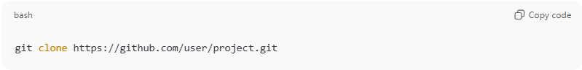
git clone https://github.com/user/project.git

Git internally creates:
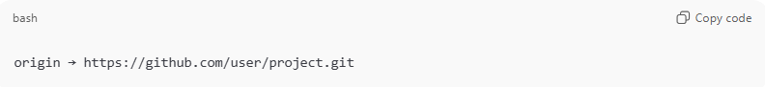
origin → https://github.com/user/project.git
So when you run:
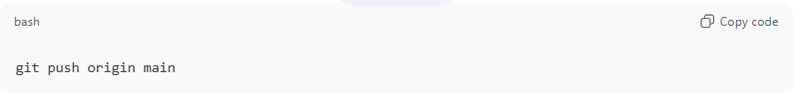
git push origin main
It means:
Push my code to the remote repo called origin.
You can see your remotes with:
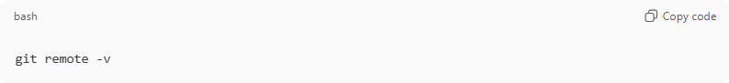
git remote -v

Command to Set Upstream Tracking
# Source: AI Source: Provided by: [Data Path: Persons Table -> ID Column: 1, Name_En Column: Motasem Essam] -> From: [Chatgpt (GPT‑5 Mini)] on [2/19/2026]
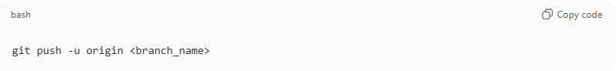
git push -u origin <branch_name>
Example:
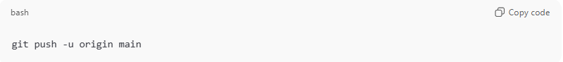
git push -u origin main
What happens here?
- origin → remote repository name
- <branch_name> → remote branch
- -u (or --set-upstream) → tells Git:
“Remember this remote branch for future push & pull.”
After this, you can just use:
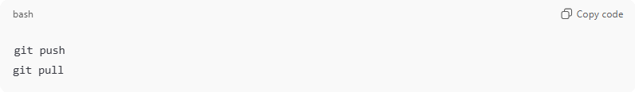
git push
git pull
No need to specify branch again.

How to Check Upstream Tracking
# Source: AI Source: Provided by: [Data Path: Persons Table -> ID Column: 1, Name_En Column: Motasem Essam] -> From: [Chatgpt (GPT‑5 Mini)] on [2/19/2026]
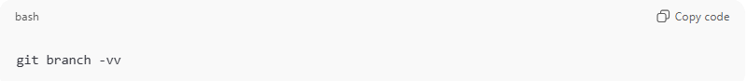
git branch -vv
Example output:
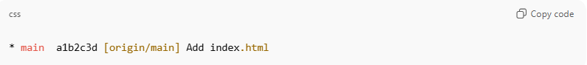
* main a1b2c3d [origin/main] Add index.html
- [origin/main] → your local main is tracking remote origin/main.

If Upstream is NOT Set
# Source: AI Source: Provided by: [Data Path: Persons Table -> ID Column: 1, Name_En Column: Motasem Essam] -> From: [Chatgpt (GPT‑5 Mini)] on [2/19/2026]
When you run:
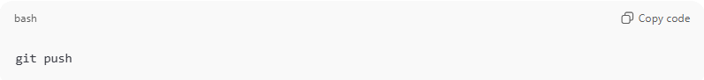
git push
You may see:
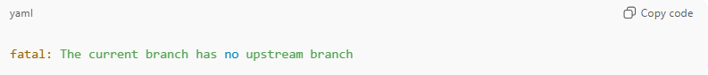
fatal: The current branch has no upstream branch
Fix it by setting upstream:
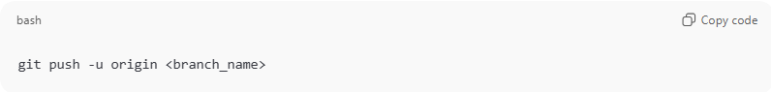
git push -u origin <branch_name>

Change Upstream Branch
# Source: AI Source: Provided by: [Data Path: Persons Table -> ID Column: 1, Name_En Column: Motasem Essam] -> From: [Chatgpt (GPT‑5 Mini)] on [2/19/2026]
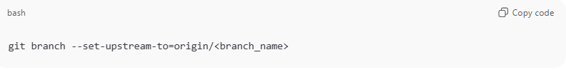
If you want to link your branch to a different remote branch:
git branch --set-upstream-to=origin/<branch_name>

Example
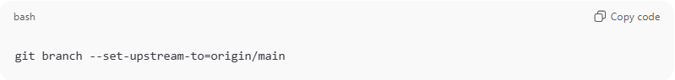
git branch --set-upstream-to=origin/main

Now your local main branch is connected to origin/main, so you can just run:
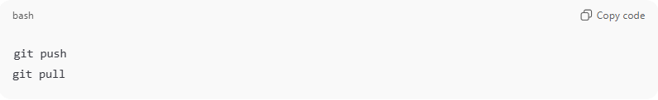

Quick Summary
# Source: AI Source: Provided by: [Data Path: Persons Table -> ID Column: 1, Name_En Column: Motasem Essam] -> From: [Chatgpt (GPT‑5 Mini)] on [2/19/2026]
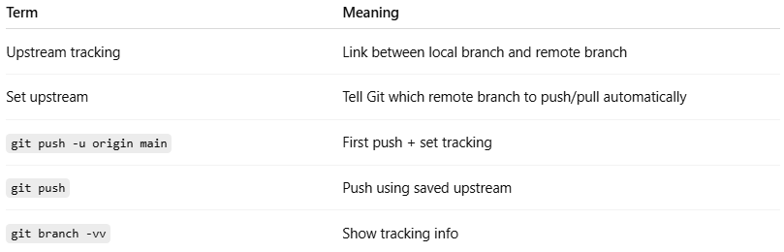
Term | Meaning
Upstream tracking | Link between local branch and remote branch
Set upstream | Tell Git which remote branch to push/pull automatically
git push -u origin main | First push + set tracking
git push | Push using saved upstream
git branch -vv | Show tracking info

Simple Concept
# Source: AI Source: Provided by: [Data Path: Persons Table -> ID Column: 1, Name_En Column: Motasem Essam] -> From: [Chatgpt (GPT‑5 Mini)] on [2/19/2026]
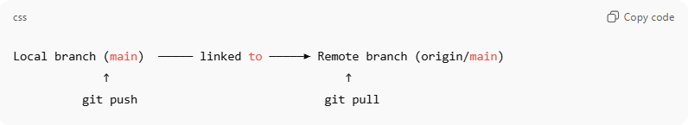
Local branch (main) ───── linked to ─────► Remote branch (origin/main)
↑ ↑
git push git pull

Push Changes to Remote
# Source: AI Source: Provided by: [Data Path: Persons Table -> ID Column: 1, Name_En Column: Motasem Essam] -> From: [Chatgpt (GPT‑5 Mini)] on [2/19/2026]
Case: Using git push (without branch name)
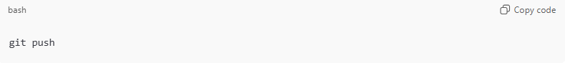
git push

What this does:
- Pushes commits from your current local branch to its tracked (upstream) remote branch.
- Works only if the branch is already linked to a remote branch.
- Usually happens after you previously used:
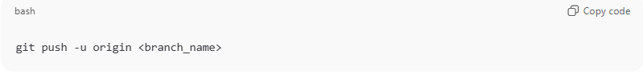
git push -u origin <branch_name>

First Time Pushing a New Branch
# Source: AI Source: Provided by: [Data Path: Persons Table -> ID Column: 1, Name_En Column: Motasem Essam] -> From: [Chatgpt (GPT‑5 Mini)] on [2/19/2026]
If you run:
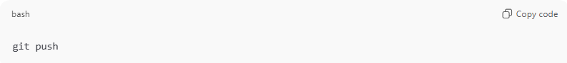
git push
and Git shows an error like:
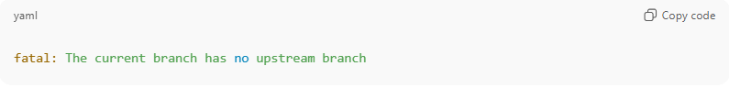
fatal: The current branch has no upstream branch
It means your branch is not linked to any remote branch yet.

Fix (set upstream branch):
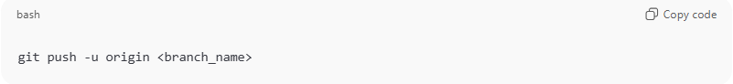
git push -u origin <branch_name>
Example:
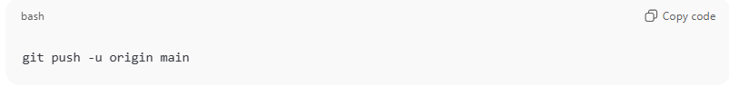
git push -u origin main

After this, you can use simply:
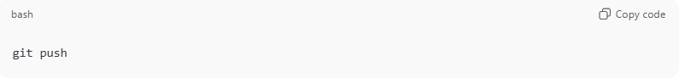
git push
for future pushes.

What git push Uses Automatically
# Source: AI Source: Provided by: [Data Path: Persons Table -> ID Column: 1, Name_En Column: Motasem Essam] -> From: [Chatgpt (GPT‑5 Mini)] on [2/19/2026]
When upstream is set, git push automatically uses:
- Remote: origin (default remote)
- Branch: your current branch
Equivalent to:
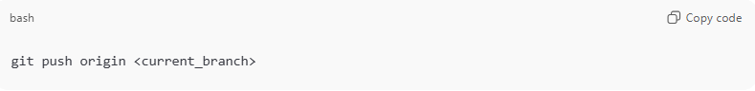
git push origin <current_branch>

Common Situations
# Source: AI Source: Provided by: [Data Path: Persons Table -> ID Column: 1, Name_En Column: Motasem Essam] -> From: [Chatgpt (GPT‑5 Mini)] on [2/19/2026]
1. Normal Push (after upstream set)
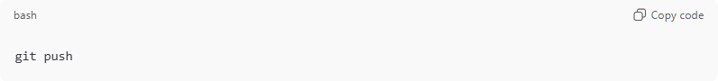
git push
Pushes new commits to remote.

2. Nothing to Push
If no new commits exist:
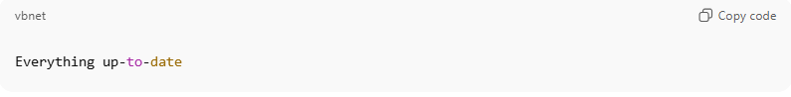
Everything up-to-date

3. After Amend or Rebase
If history changed, normal push may fail:
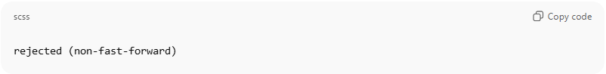
rejected (non-fast-forward)
Use force push carefully:
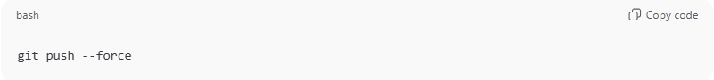
git push --force
⚠ This rewrites remote history.

Quick Summary
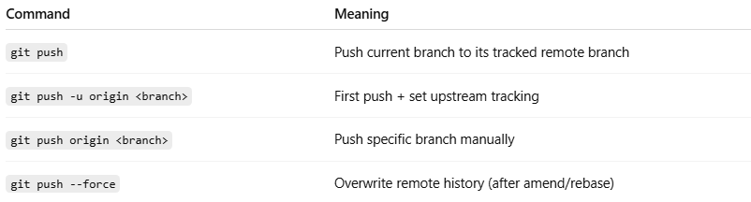
Command | Meaning
git push | Push current branch to its tracked remote branch
git push -u origin <branch> | First push + set upstream tracking
git push origin <branch> | Push specific branch manually
git push --force | Overwrite remote history (after amend/rebase)

Push All Branches
# Source: AI Source: Provided by: [Data Path: Persons Table -> ID Column: 1, Name_En Column: Motasem Essam] -> From: [Chatgpt (GPT‑5 Mini)] on [2/19/2026]
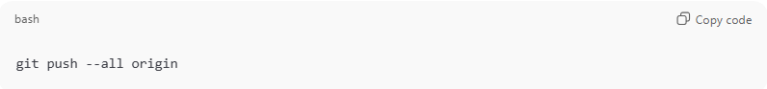
git push --all origin
- Pushes all local branches to the remote repository.

Push Tags (Optional)
# Source: AI Source: Provided by: [Data Path: Persons Table -> ID Column: 1, Name_En Column: Motasem Essam] -> From: [Chatgpt (GPT‑5 Mini)] on [2/19/2026]
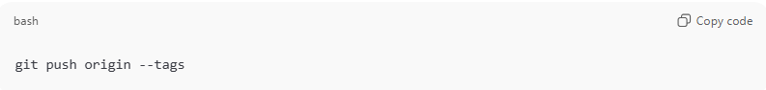
git push origin --tags
- Pushes all tags from local to remote repository.

Force Push (Use Carefully)
# Source: AI Source: Provided by: [Data Path: Persons Table -> ID Column: 1, Name_En Column: Motasem Essam] -> From: [Chatgpt (GPT‑5 Mini)] on [2/19/2026]
If you amended commits or rebased local commits, the history may differ from the remote. To overwrite the remote:
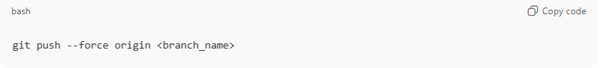
git push --force origin <branch_name>
⚠ Warning:
- This rewrites remote history.
- Only do this if you are sure nobody else is working on the same branch.

Verify Remote Status
# Source: AI Source: Provided by: [Data Path: Persons Table -> ID Column: 1, Name_En Column: Motasem Essam] -> From: [Chatgpt (GPT‑5 Mini)] on [2/19/2026]
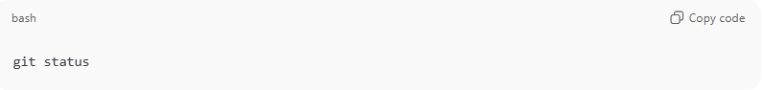
git status
- Confirms if your local branch is ahead of the remote or up to date.
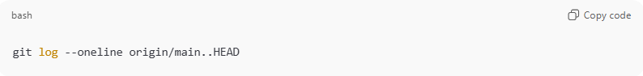
git log --oneline origin/main..HEAD
- Shows commits in your local branch that are not yet pushed to remote.

One-Line Push After Commit
# Source: AI Source: Provided by: [Data Path: Persons Table -> ID Column: 1, Name_En Column: Motasem Essam] -> From: [Chatgpt (GPT‑5 Mini)] on [2/19/2026]
After committing locally:
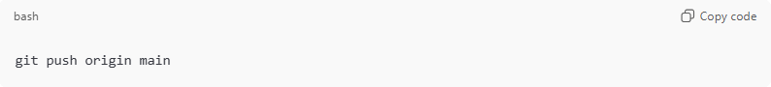
git push origin main
- Sends your local changes to the remote in one step.
Example Full Workflow from Workspace → Remote in One Line:
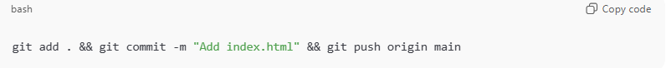
git add . && git commit -m "Add index.html" && git push origin main
- Stages all changes, commits them locally, and pushes them to remote in one line.

✅ Summary Table
# Source: AI Source: Provided by: [Data Path: Persons Table -> ID Column: 1, Name_En Column: Motasem Essam] -> From: [Chatgpt (GPT‑5 Mini)] on [2/19/2026]
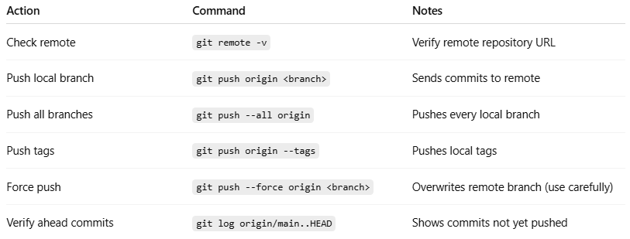
Action | Command | Notes
Check remote | git remote -v | Verify remote repository URL
Push local branch | git push origin <branch> | Sends commits to remote
Push all branches | git push --all origin | Pushes every local branch
Push tags | git push origin --tags | Pushes local tags
Force push | git push --force origin <branch> | Overwrites remote branch (use carefully)
Verify ahead commits | git log origin/main..HEAD | Shows commits not yet pushed

💡 Tip:
- Always pull (git pull) before pushing if others are working on the same branch to avoid conflicts.
- Use force push only after careful review to avoid overwriting others’ work.

Example

Check staged changes
# Source: ScreenShots Source: Provided by: [Persons Table -> ID Column: 1, Name_En Column: Motasem Essam] -> Tool: [Lightshot Program] -> From [Windows] on [2/19/2026]

From Remote repository to Local repository
# Source: AI Source: Provided by: [Data Path: Persons Table -> ID Column: 1, Name_En Column: Motasem Essam] -> From: [Chatgpt (GPT‑5 Mini)] on [2/19/2026]
Got it 👍 — here is a clean section you can add to your topic.
This means bringing changes from the remote repo (e.g., GitHub) into your local repo.
There are 3 main ways: pull, fetch, and clone.

Pull Changes (Fetch + Merge)
# Source: AI Source: Provided by: [Data Path: Persons Table -> ID Column: 1, Name_En Column: Motasem Essam] -> From: [Chatgpt (GPT‑5 Mini)] on [2/19/2026]
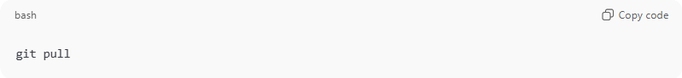
git pull
What it does:
- Downloads changes from the tracked remote branch.
- Automatically merges them into your current local branch.
- Requires upstream tracking to be set.
Equivalent to:
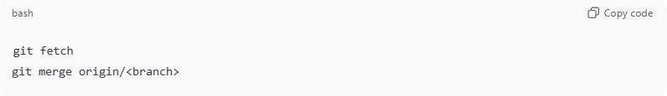
git fetch
git merge origin/<branch>

Pull From Specific Branch
# Source: AI Source: Provided by: [Data Path: Persons Table -> ID Column: 1, Name_En Column: Motasem Essam] -> From: [Chatgpt (GPT‑5 Mini)] on [2/19/2026]
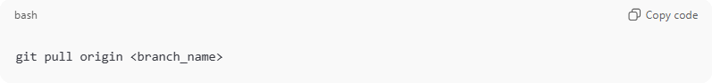
git pull origin <branch_name>
Example:
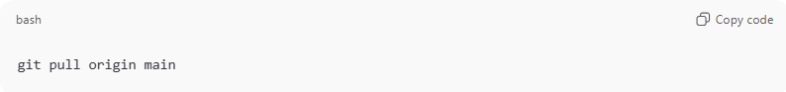
git pull origin main
- Downloads and merges changes from origin/main into your current branch.

2. Fetch Changes (Download Only)
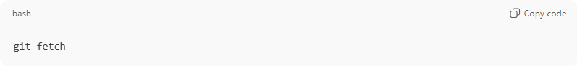
git fetch
What it does:
- Downloads changes from remote.
- Does NOT merge them automatically.
- Lets you review changes before merging.
After fetching, you can merge manually:
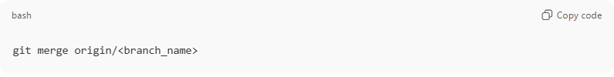
git merge origin/<branch_name>

When to Use Fetch
- To check remote changes safely before merging.
- To avoid automatic merge conflicts.
- To inspect differences:
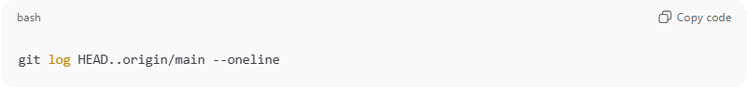
git log HEAD..origin/main --oneline

Clone Repository (First Time Only)
# Source: AI Source: Provided by: [Data Path: Persons Table -> ID Column: 1, Name_En Column: Motasem Essam] -> From: [Chatgpt (GPT‑5 Mini)] on [2/19/2026]
If you don’t have the repo locally yet:
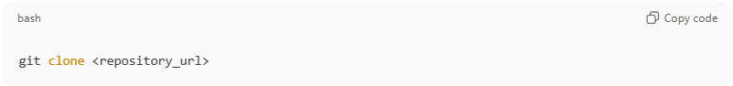
git clone <repository_url>
Example:
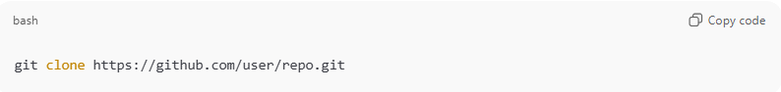
git clone https://github.com/user/repo.git
What it does:
- Downloads the entire repository.
- Creates a local repo.
- Automatically sets upstream tracking.
- Default branch is checked out (usually main).

Pull With Rebase (Optional)
# Source: AI Source: Provided by: [Data Path: Persons Table -> ID Column: 1, Name_En Column: Motasem Essam] -> From: [Chatgpt (GPT‑5 Mini)] on [2/19/2026]
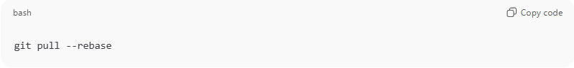
git pull --rebase
- Fetches remote changes.
- Reapplies your local commits on top of remote commits.
- Keeps history linear and clean.

Common Situations
# Source: AI Source: Provided by: [Data Path: Persons Table -> ID Column: 1, Name_En Column: Motasem Essam] -> From: [Chatgpt (GPT‑5 Mini)] on [2/19/2026]
Already Up to Date
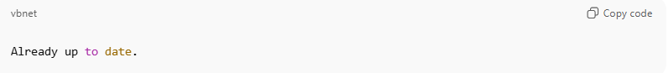
Already up to date.
No new remote changes.

Merge Conflict
# Source: AI Source: Provided by: [Data Path: Persons Table -> ID Column: 1, Name_En Column: Motasem Essam] -> From: [Chatgpt (GPT‑5 Mini)] on [2/19/2026]
If local and remote changed the same lines:
- Git pauses and asks you to resolve conflicts.
- After fixing:
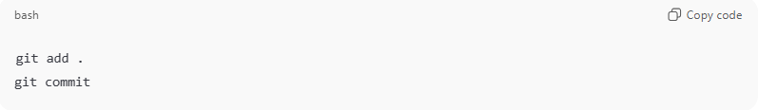
git add .
git commit

Local Behind Remote
Check commits you don’t have yet:
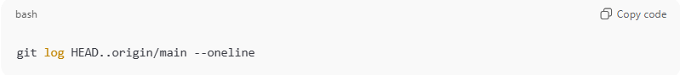
git log HEAD..origin/main --oneline

Quick Summary
# Source: AI Source: Provided by: [Data Path: Persons Table -> ID Column: 1, Name_En Column: Motasem Essam] -> From: [Chatgpt (GPT‑5 Mini)] on [2/19/2026]
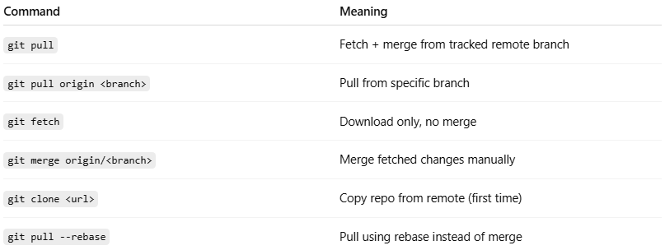
Command | Meaning
git pull | Fetch + merge from tracked remote branch
git pull origin <branch> | Pull from specific branch
git fetch | Download only, no merge
git merge origin/<branch> | Merge fetched changes manually
git clone <url> | Copy repo from remote (first time)
git pull --rebase | Pull using rebase instead of merge

Simple Flow
# Source: AI Source: Provided by: [Data Path: Persons Table -> ID Column: 1, Name_En Column: Motasem Essam] -> From: [Chatgpt (GPT‑5 Mini)] on [2/19/2026]
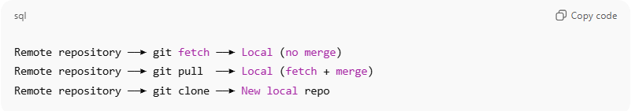
Remote repository ──► git fetch ──► Local (no merge)
Remote repository ──► git pull ──► Local (fetch + merge)
Remote repository ──► git clone ──► New local repo

From Remote repository to Workspace
# Source: AI Source: Provided by: [Data Path: Persons Table -> ID Column: 1, Name_En Column: Motasem Essam] -> From: [Chatgpt (GPT‑5 Mini)] on [2/19/2026]
Got it 👍 — here is a clear section for From Remote Repository → Workspace.
This means: bringing changes from the remote repo directly into your working directory (workspace) so you can see and edit the updated files.
To move changes from remote into your workspace, Git must download them and update your working tree. The main commands are:
- git pull (most common)
- git fetch + git merge
- git fetch + git checkout (or switch)

Direct Update to Workspace (Pull)
# Source: AI Source: Provided by: [Data Path: Persons Table -> ID Column: 1, Name_En Column: Motasem Essam] -> From: [Chatgpt (GPT‑5 Mini)] on [2/19/2026]
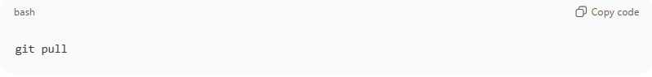
git pull
What it does:
- Downloads changes from the tracked remote branch.
- Merges them into your local branch.
- Updates files in your workspace immediately.
So the flow is:
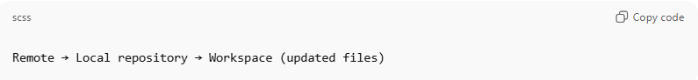
Remote → Local repository → Workspace (updated files)

Pull From Specific Branch
# Source: AI Source: Provided by: [Data Path: Persons Table -> ID Column: 1, Name_En Column: Motasem Essam] -> From: [Chatgpt (GPT‑5 Mini)] on [2/19/2026]
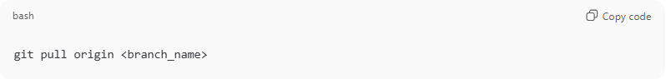
git pull origin <branch_name>
Example:
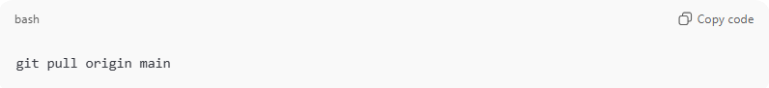
git pull origin main

Fetch First, Then Update Workspace Manually
# Source: AI Source: Provided by: [Data Path: Persons Table -> ID Column: 1, Name_En Column: Motasem Essam] -> From: [Chatgpt (GPT‑5 Mini)] on [2/19/2026]
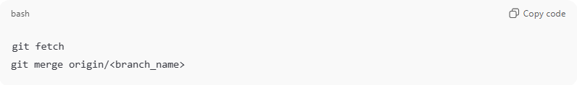
git fetch
git merge origin/<branch_name>
What happens:
- git fetch → downloads remote changes (no workspace update yet).
- git merge → applies them → workspace gets updated.

Update Workspace Without Merge Commit (Rebase)
# Source: AI Source: Provided by: [Data Path: Persons Table -> ID Column: 1, Name_En Column: Motasem Essam] -> From: [Chatgpt (GPT‑5 Mini)] on [2/19/2026]
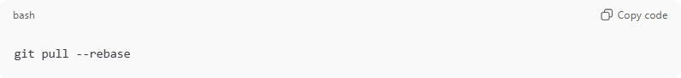
git pull --rebase
What it does:
- Downloads remote changes.
- Reapplies your local commits on top.
- Updates workspace with a clean linear history.

Switch Workspace to Remote Version (Overwrite Local Files)
# Source: AI Source: Provided by: [Data Path: Persons Table -> ID Column: 1, Name_En Column: Motasem Essam] -> From: [Chatgpt (GPT‑5 Mini)] on [2/19/2026]
If you want your workspace to match the remote exactly:
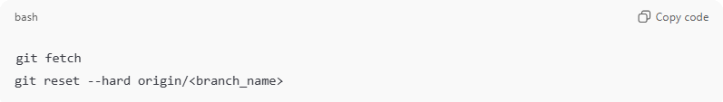
git fetch
git reset --hard origin/<branch_name>
⚠ Warning:
- This overwrites your workspace and local changes.
- Use only if you want to discard local modifications.

Restore a Single File From Remote to Workspace
# Source: AI Source: Provided by: [Data Path: Persons Table -> ID Column: 1, Name_En Column: Motasem Essam] -> From: [Chatgpt (GPT‑5 Mini)] on [2/19/2026]
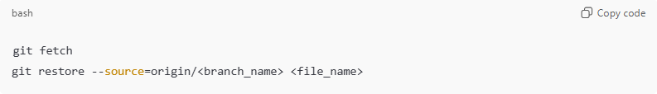
git fetch
git restore --source=origin/<branch_name> <file_name>
Example:
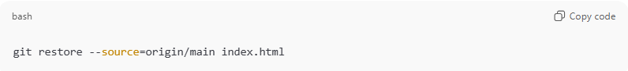
git restore --source=origin/main index.html
- Updates only that file in your workspace from remote.

Common Results
# Source: AI Source: Provided by: [Data Path: Persons Table -> ID Column: 1, Name_En Column: Motasem Essam] -> From: [Chatgpt (GPT‑5 Mini)] on [2/19/2026]
Already Up To Date
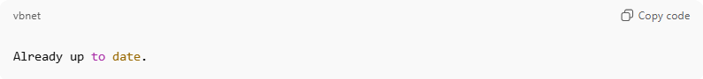
Already up to date.
No changes from remote.

Merge Conflict
# Source: AI Source: Provided by: [Data Path: Persons Table -> ID Column: 1, Name_En Column: Motasem Essam] -> From: [Chatgpt (GPT‑5 Mini)] on [2/19/2026]
If both local and remote changed the same lines:
- Git stops and asks you to resolve conflicts.
- After fixing:
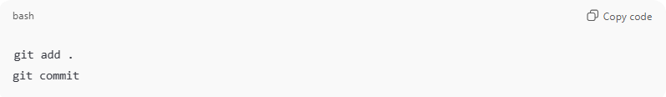
git add .
git commit

Quick Summary
# Source: AI Source: Provided by: [Data Path: Persons Table -> ID Column: 1, Name_En Column: Motasem Essam] -> From: [Chatgpt (GPT‑5 Mini)] on [2/19/2026]
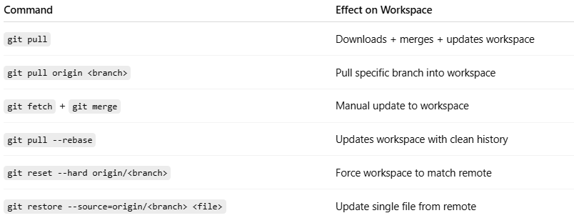
Command | Effect on Workspace
git pull | Downloads + merges + updates workspace
git pull origin <branch> | Pull specific branch into workspace
git fetch + git merge | Manual update to workspace
git pull --rebase | Updates workspace with clean history
git reset --hard origin/<branch> | Force workspace to match remote
git restore --source=origin/<branch> <file> | Update single file from remote

Simple Flow
# Source: AI Source: Provided by: [Data Path: Persons Table -> ID Column: 1, Name_En Column: Motasem Essam] -> From: [Chatgpt (GPT‑5 Mini)] on [2/19/2026]
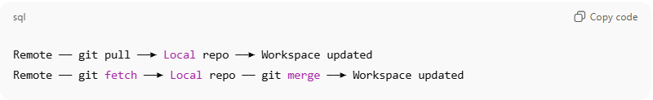
Remote ── git pull ──► Local repo ──► Workspace updated
Remote ── git fetch ──► Local repo ── git merge ──► Workspace updated

